**Covid Tracker**

* Surge Link of the project : <http://vandnacovidtracker.surge.sh/dashboard>
* Admin User Login Details :   
  Username : admin, Password:admin

Front Page :

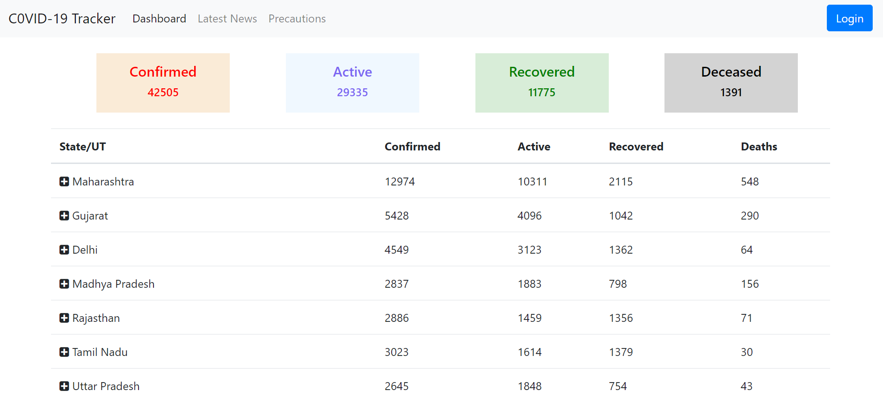

Here Above 4 tabs of Confirmed, active, Recovered and deceased is the data of total cases in India.

And below are the states details.

* To see the district details, click on any state you want see details of. Like :

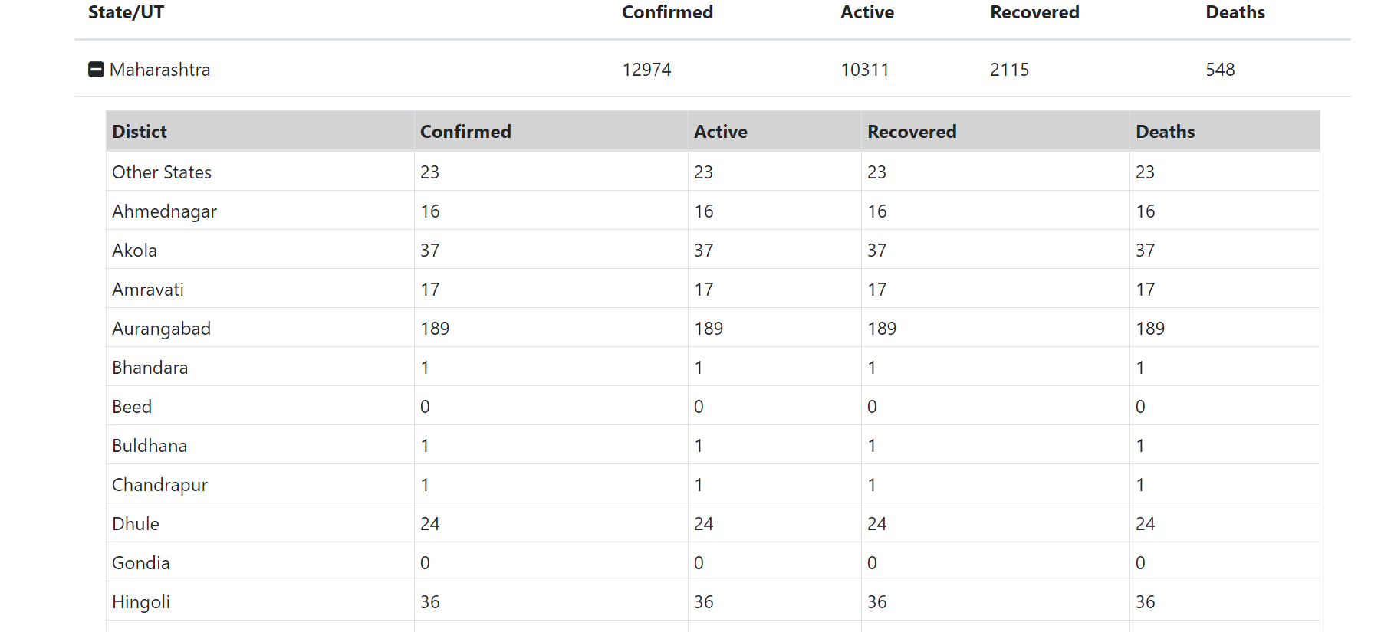

* When user is logged as admin, only then user can add news and then the option will be added in the navbar.

